COMMONWEALTH COMMUNITY
DEVELOPMENT ACADEMY

Academic Center Corporate Office Elementary School
10731-37 W. Mc Nichols 13504 Justine 13477 Eureka
Detroit, MI 48221 Detroit, MI. 48212 Detroit, MI. 48212
313.864-6627 313.891-6802 313.366-9470
313.864-6628 Fax 313.366-9511 Fax 313.366-9471 Fax
Mrs. Angela Moore, Superintendent/ Principal

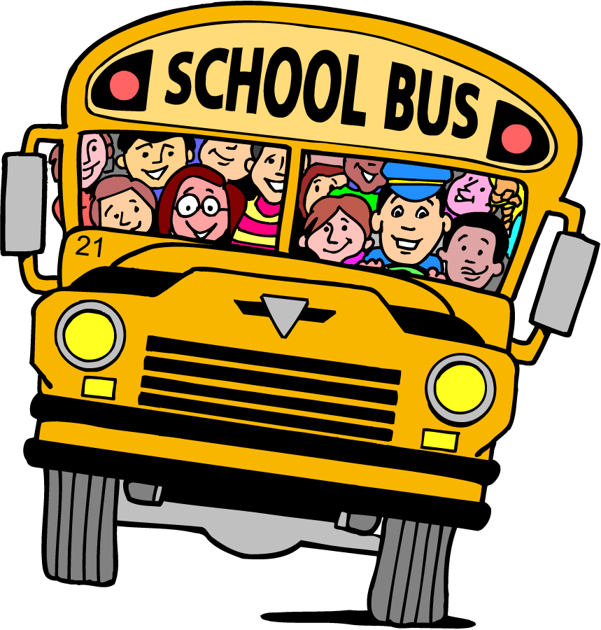
Transportation Request Form 2026-2027
(Routes Subject to change from 2025-2026 School Year)

REQUEST DATE: _______________________________________________

STUDENT NAME: ______________________________________________

GRADE LEVEL: ____________

ADDRESS: _____________________________________________________

TELEPHONE: _____________________ ALTERNATE NUMBER: _____________________

SIBLINGS: ____________________________________ GRADE LEVEL: _____________

___________________________________________ ________________

___________________________________________ ________________

___________________________________________ _______________

Please indicate the bus stop at which you will like for a student to be picked up & dropped off:

MAJOR CROSS STREETS: ______________________________________________
(Example: Seven Mile and Conant)

THERE WILL BE NO FRONT DOOR OR CURBSIDE PICK UPS – Must be at designated intersection/stop.
SAFETY IS OUR FIRST PRIORITY! Students participating in the transportation must abide by all rules, guidelines and laws. Students are not permitted in the aisle, to stand, to eat or drink on the bus. Students are not permitted to hang out of the windows or throw anything out of the windows. The bus must be clean and remain barrier free. There is ABSOLUTE ZERO TOLERANCE for these behaviors, including cursing, fighting, and disrespect/insubordination. Failure to comply will result in disciplinary action, up to and including expulsion.
Parent Signature:

